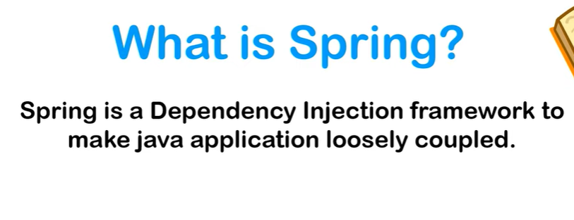

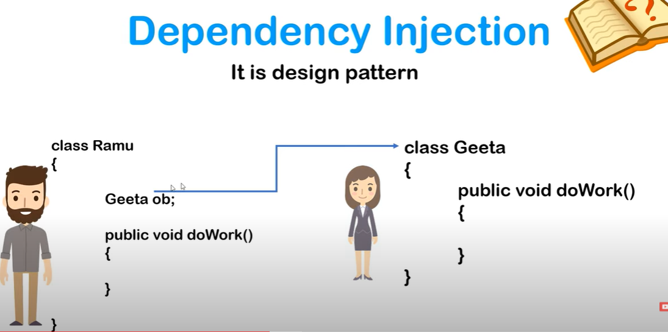

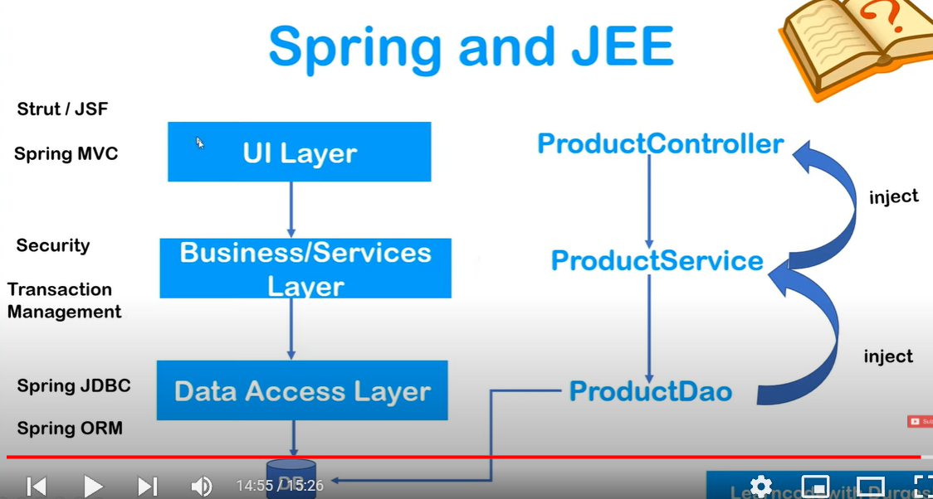

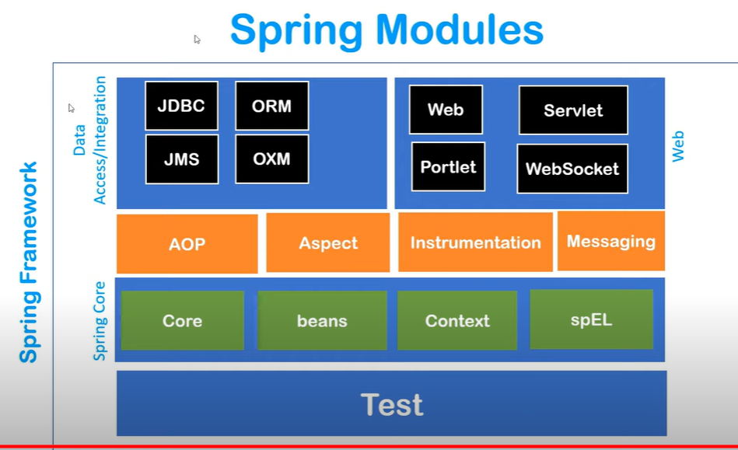

JMS (**Java Message Service**) is a Java Message Oriented Middleware used to send messages between clients and works by sending messages to a message queue which are then taken when possible to execute a transaction. This post will focus on implementing JMS with Spring Boot, which doesn't take long at all to setup.

Spring OXM stands **for Spring Object XML Mappers** and it is a module available in Spring to ease the mapping between java objects and XML documents. The module is extensible and hence it provides integration with various popular frameworks like Castor, JAXB, XmlBeans and XStream.

What is Spring IOC Container

* Create the object
* Hold them in a memory
* Inject them in another object as required

Spring IOC container ko 2 cheezain deni hoti hai Beans that means POJO’s and XML Configurations xml config mai humay yai batana hota hai k konsa bean kis par dependent hai kon konsi properties values saari define karni hoti hai

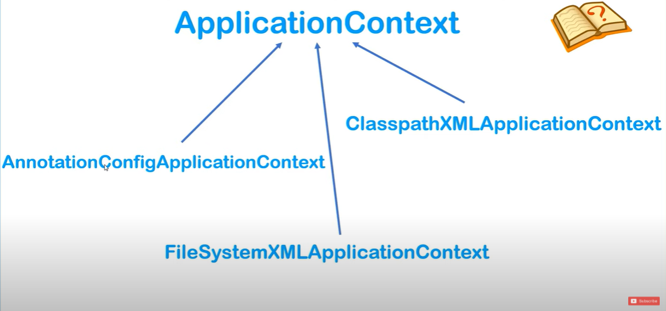

Application Context IOC container ko represent karta hai or iski implementation 3 tarah sai hoti hai normally ClasspathXml use kartay hai.

# Ways of Injecting dependencies | Types of dependencies handled by IOC Container

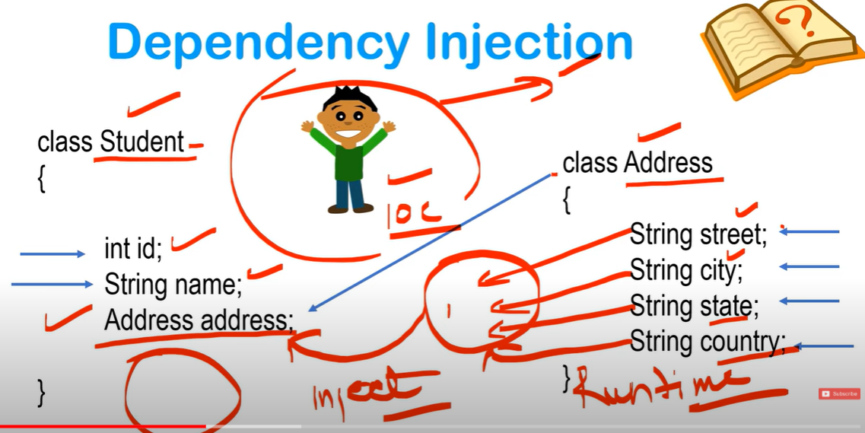

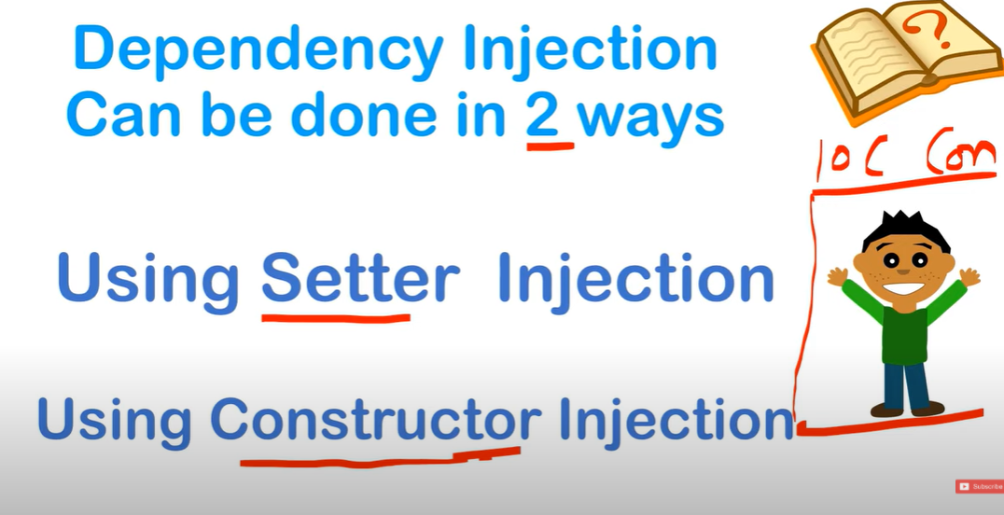  
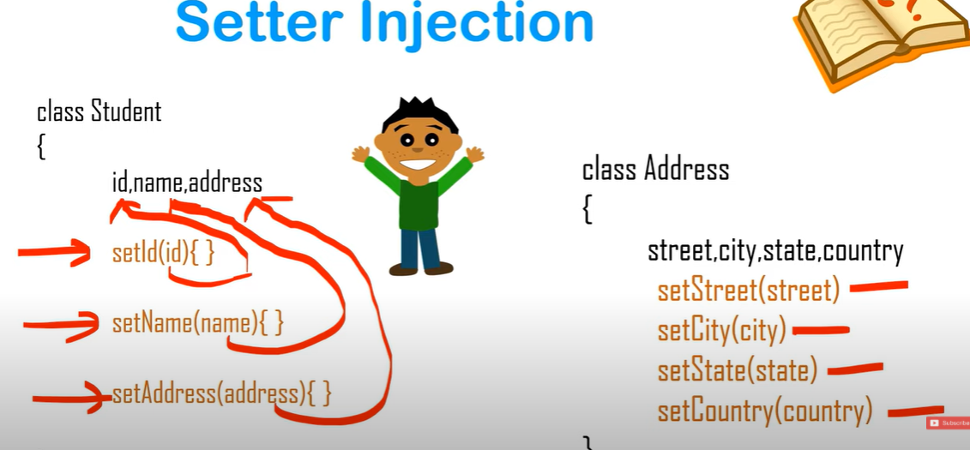

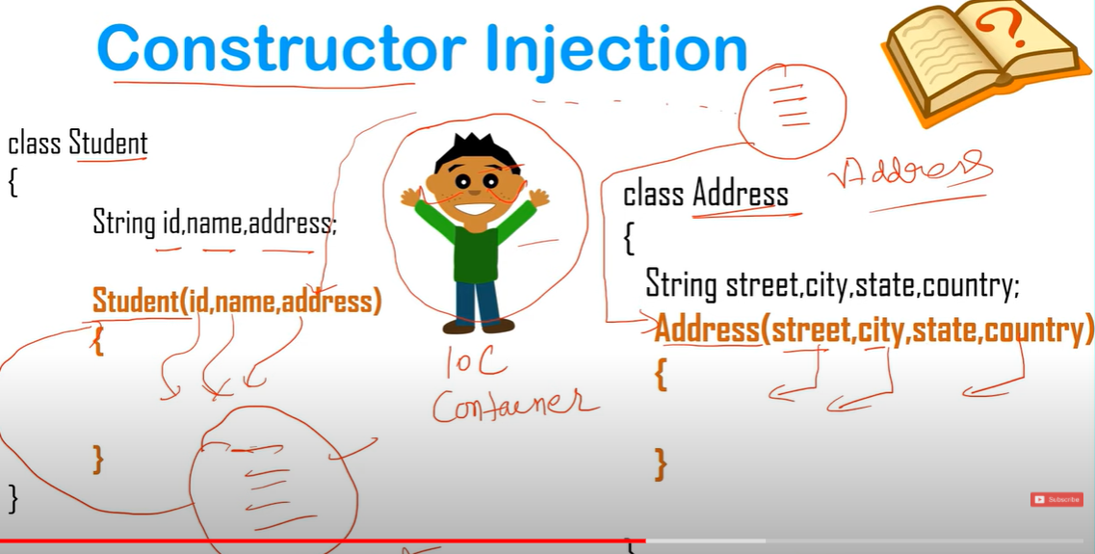

Agar kisi bhi class ki information hum IOC ko day jabhi yai object banayega or uski life cycle maintain karay ga iski ko kehtay hai beans.

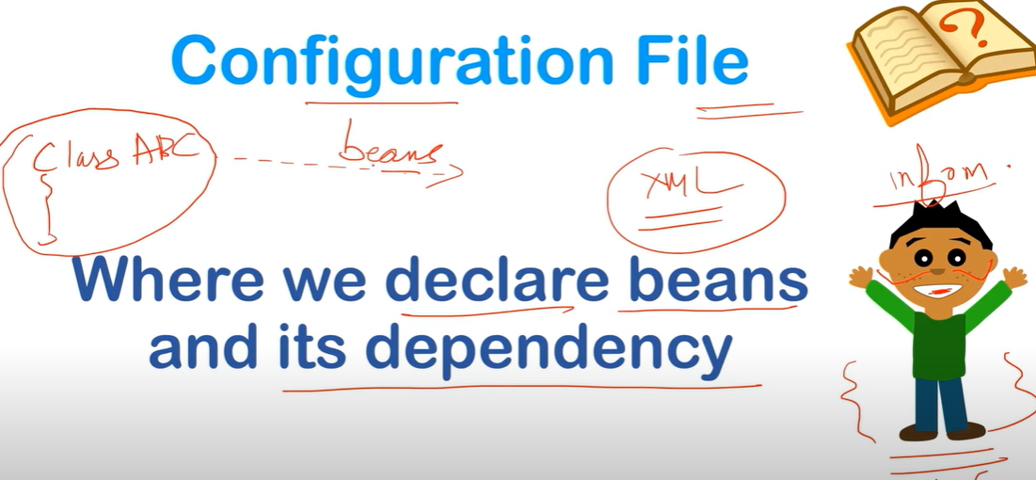

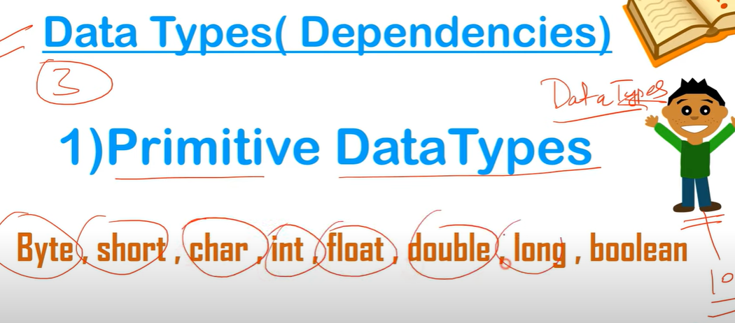

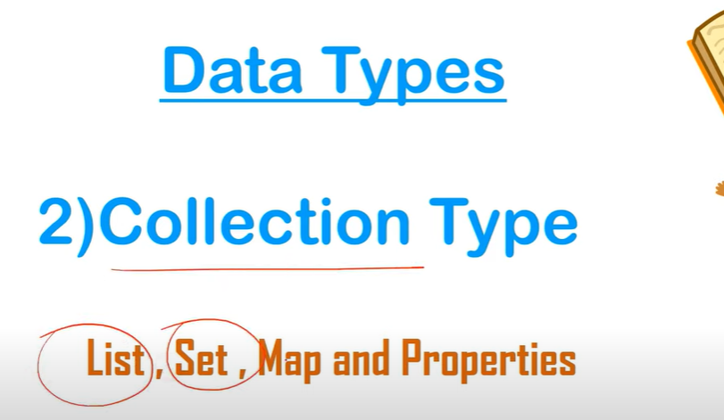

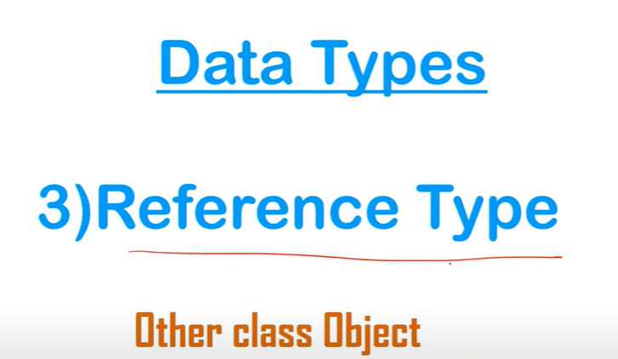

# New Maven Project | Adding Spring Dependencies | Create Config File | Setter Injection | Practical

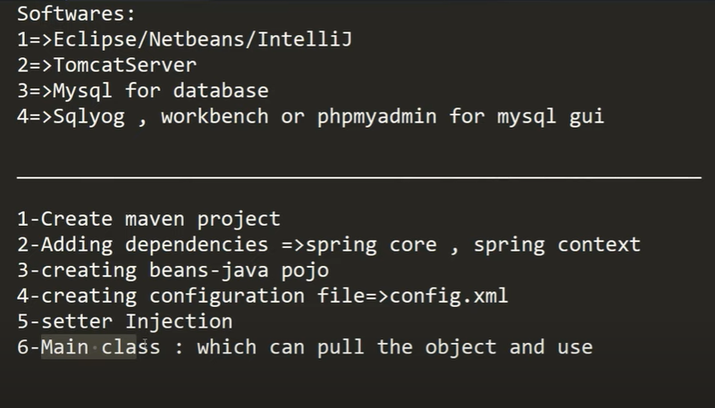

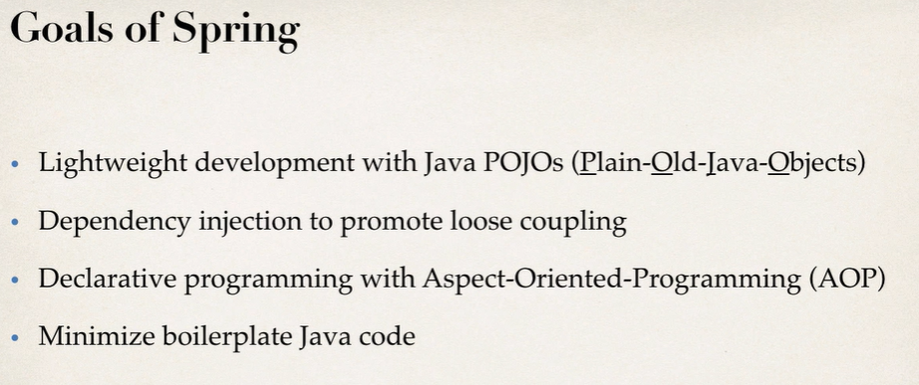

# What is Maven ?

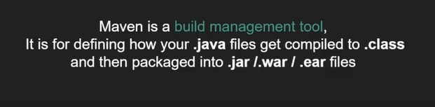

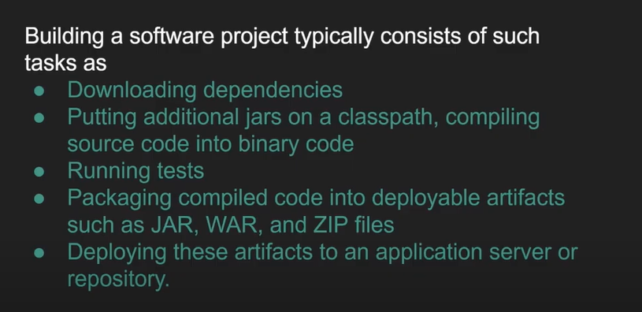

Maven automate these tasks.

**Bean Life Cycle:**

[**https://www.geeksforgeeks.org/bean-life-cycle-in-java-spring/**](https://www.geeksforgeeks.org/bean-life-cycle-in-java-spring/)

**Transactional Annotation:**

